Automatic Topic Detection in Multilingual Hotel Reviews: A Multi-Label Classification Approach
1. Introduction
This study develops a multi-label classification system assigns that zero or more topic labels, contributing to research in web care (Van Noort & Willemsen, 2012). The dataset consists of 1,000 annotated Booking.com reviews written in five languages (DE, ES, FR, GB, MX). As Italian and Dutch are included only in the test set, this presents a zero-shot multilingual classification task characterised by severe label imbalance. To address this, we applied back-translation augmentation, class-weighted loss and label-specific threshold optimisation techniques, achieving a macro F1 score of 0.7572.
2. Dataset
2.1 Pre-processing and Splitting
Each review was divided into ‘Like’ and ‘Dislike’ sections, resulting in a total of 2,000 data instances. The ‘Like’/‘Dislike’ pairs were restructured as alternating rows to fit the test data structure, and this distinction was encoded using semantic headers ([LIKED]/[DISLIKED]). Following URL removal, special character filtering and deduplication, 1,881 instances remained. We used MultilabelStratifiedShuffleSplit (Sechidis et al., 2011) to generate an 80/20 training-validation split that preserves the label distribution across both sets.
2.2 Data Augmentation via Back-Translation
Preliminary experiments showed that performance for rare labels deteriorated when back-translation was performed without data augmentation; consequently, we decided to introduce a data augmentation strategy. To address the issues of limited training data, zero-shot learning for Italian and Dutch, and label imbalance, we applied back-translation data augmentation using the deep_translator library. To prevent excessive augmentation of high-frequency classes, we restricted the augmentation targets to labels with fewer than 450 samples, and prioritised processing source instances with a single label to minimise label noise. To ensure lexical diversity, English data was back-translated via Korean, Japanese or Chinese; Italian and Dutch were generated via direct translation; and other languages were generated via back-translation or cross-language translation. The target sample size was set at 50 per label for Italian and Dutch, and 30 for all other languages. Following deduplication and quality filtering, the training set increased from 1,881 to 3,289.
3. Methodology
3.1 Model and Training
XLM-RoBERTa-Large (Conneau et al., 2020), which has been pre-trained on over 100 languages, was selected for cross-lingual transfer to unknown languages. As cross-lingual generalisation for Italian and Dutch requires multilingual representations that a bag-of-words model cannot provide, traditional approaches such as TF-IDF using logistic regression were not adopted. AutoModelForSequenceClassification (Wolf et al., 2020) was set to num_labels=20. The model was trained for 10 epochs (lr=2e-5, batch size=8, max_length=128). We used AdamW (Loshchilov & Hutter, 2019) with grouped weight decay (0.01, excluding bias and LayerNorm), a linear warm-up scheduler (10% of the step size) and gradient clipping (max_norm=1.0).
3.2 Imbalance Handling and Threshold Optimization
Applying pos_weight to BCEWithLogitsLoss increased the model’s sensitivity to minority labels. Instead of applying a uniform threshold of 0.5, we optimised the threshold for each label on the validation set via grid search (0.1–0.9, in 0.05 increments) to maximise the F1 score for each label. Whenever the validation Macro-F1 score improved, we saved the best-performing checkpoint.
4. Performance Metrics
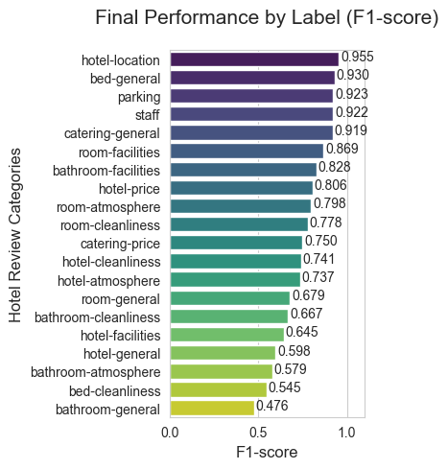
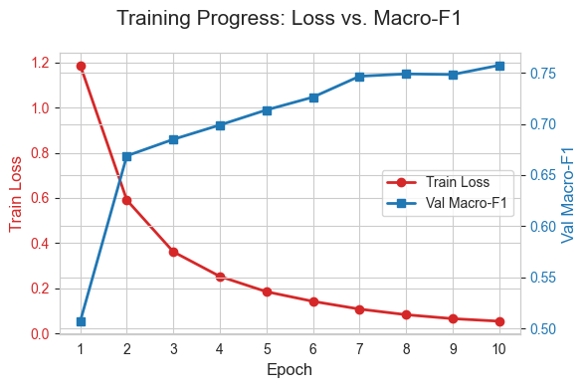
4.1 Training Progress and Per-Label Performance
Figure 1: Train Loss and Val Macro-F1 across 10 epochs
Across all epochs, the loss value decreased from 1.1876 to 0.0538, whilst the Macro-F1 score improved from 0.5073 to 0.7572, confirming that stable fine-tuning was achieved without overfitting. Labels with distinct lexical markers, such as hotel-location (0.955), parking (0.923) and staff (0.922), recorded the highest F1 scores. bathroom-general (0.476) and hotel-general (0.598) showed the lowest performance, which is consistent with the codebook definition of these as semantically broad categories lacking explicit thematic attributes.
Figure 2: Per-label F1 at best epoch
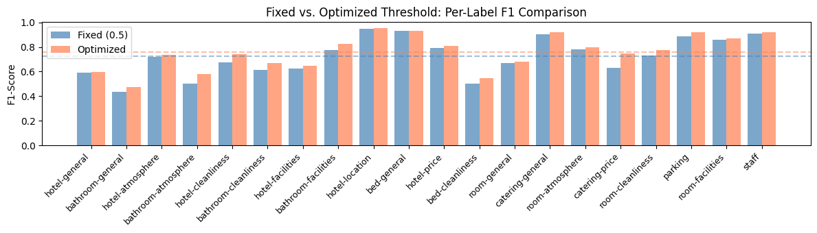
4.2 Threshold Impact
Figure 3: Fixed vs. Optimized threshold
Through threshold optimisation, the Macro-F1 score improved from 0.7244 to 0.7572 (+0.0328), with the greatest improvement observed particularly for rare labels.
Label | Precision | Recall
staff | 0.929 | 0.915
bathroom-general | 0.357 | 0.714
Table 1: Precision and Recall for best/worst labels
The best-performing staff demonstrated a high level of balance, with both Precision and Recall at around 0.92, confirming the clarity of the data. In contrast, bathroom-general, whilst achieving a Recall of 0.714 through data augmentation, exhibited an extreme imbalance in metrics, with Precision plummeting to 0.357 due to ambiguity.
5. Limitations
As the validation set does not contain examples in Italian or Dutch, direct cross-lingual evaluation is not possible. Consequently, generalisation to the test languages relies entirely on XLM-RoBERTa’s zero-shot capabilities. Machine translation can introduce semantic noise, particularly in the case of short, colloquial expressions. Rare labels remain a challenging issue due to data scarcity and the broad semantic scope defined in the codebook, which leads to inherent ambiguity with co-occurring categories. The tokeniser is set to ‘max_length=128`, meaning that approximately 3% of long examples may be truncated, potentially resulting in the loss of context-relevant information. The thresholds for each label were optimised on the validation set, which may result in slight overfitting to the validation distribution. Finally, the validation set, comprising 377 examples, may yield statistically unstable F1 scores for minority labels.
6. Conclusion
This study presents a multilingual multi-label topic classification system utilising XLM-RoBERTa-Large, back-translation augmentation, class-weighted loss, and label-specific threshold optimisation techniques, achieving a Macro F1 score of 0.7572. Future research topics may include translation quality filtering, active learning for rare labels, and the use of Italian/Dutch validation data for direct cross-lingual evaluation.
7. References
- Conneau, A., Khandelwal, K., Goyal, N., Chaudhary, V., Wenzek, G., Guzmán, F., Grave, E., Ott, M., Zettlemoyer, L., & Stoyanov, V. (2020). Unsupervised Cross-lingual Representation Learning at Scale. In Proceedings of the 58th Annual Meeting of the Association for Computational Linguistics (pp. 8440–8451). Association for Computational Linguistics. https://doi.org/10.18653/v1/2020.acl-main.747
- Loshchilov, I., & Hutter, F. (2019). Decoupled Weight Decay Regularization. In International Conference on Learning Representations (ICLR). https://openreview.net/forum?id=Bkg6RiCqY7
- Sechidis, K., Tsoumakas, G., & Vlahavas, I. (2011). On the stratification of multi-label data. In European Conference on Machine Learning and Knowledge Discovery in Databases (ECML PKDD 2011) (pp. 145–158).
- van Noort, G., & Willemsen, L. M. (2012). Online Damage Control: The Effects of Proactive Versus Reactive Webcare Interventions in Consumer-generated and Brand-generated Platforms. Journal of Interactive Marketing, 26(3), 131–140. https://doi.org/10.1016/j.intmar.2011.07.001
- Wolf, T., Debut, L., Sanh, V., Chaumond, J., Delangue, C., Moi, A., Cistac, P., Rault, T., Louf, R., Funtowicz, M., Davison, J., Shleifer, S., von Platen, P., Ma, C., Jernite, Y., Plu, J., Xu, C., Scao, T. L., Gugger, S., Drame, M., Lhoest, Q., & Rush, A. (2020). Transformers: State-of-the-Art Natural Language Processing. In Proceedings of the 2020 Conference on Empirical Methods in Natural Language Processing: System Demonstrations (pp. 38–45). Association for Computational Linguistics. https://doi.org/10.18653/v1/2020.emnlp-demos.6

